Week Ending: 17.04.26

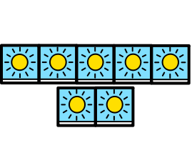

Stars of the Week

  Early Years | Everyone for a great first week back in school. You have all worked so hard and have been superstars!
  Green Class | A Pupil in Green Class for fantastic engagement and interaction with (and alongside) her peers.
  Red Class | Freddie for fantastic engagement in our new sensory exploration session.
  Purple Class | The Whole Class for having a great start to the summer term. Well done Purple Class!
  Blue Class | Melanie for her fantastic recall and brilliant sentence building in Colourful Semantics. Well done, Melanie!
  Yellow Class | Shayla for her prolonged focus and for the following of key word instructions during activities this week in class.
  The Arc | A Side: Simi for being alert and responsive during our painting session.  B Side: Kallum for joining in with his Body Awareness session, and for completing some tasks independently.
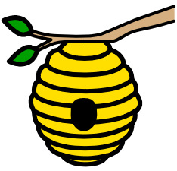  The Hive | James for fantastic communication and for following instructions on our trip this week.
  The Hub | Daisy-May for working hard on her targets, and for being sociable with everyone.

