Communication and Interaction | Cognition and Learning
  This term, children will be immersed in lots of exciting opportunities to communicate through our Pets topic and shared daily routines. Through stories, songs, play and sensory experiences linked to The Tiger Who Came to Tea, children will make choices, take turns and share attention with adults and peers. We will support children to use objects, photographs, symbols, signs and spoken words to express preferences, respond to familiar instructions and enjoy communicating together. | 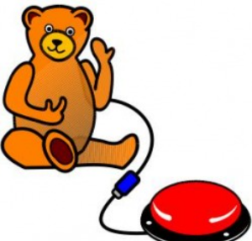  Children will explore learning through hands-on, playful activities inspired by pets and real-life experiences. They will enjoy discovering cause and effect using interactive toys and switches, matching pets to their homes and equipment, and taking part in sorting, matching and problem-solving activities. Learning is carefully repeated and built into play, helping children develop curiosity, confidence and a growing understanding of the world around them.
Physical and Sensory | Social, Emotional and Mental Health
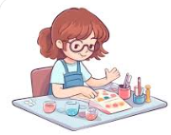  This term offers lots of opportunities for movement, exploration and sensory fun. Children will take part in soft play, PE and obstacle courses inspired by animal movements, as well as fine motor activities such as scooping, pouring and creative play. Ang will lead weekly movement sessions, using actions and movement linked to The Tiger Who Came to Tea to support coordination, body awareness and enjoyment. Sensory play and outdoor learning in our sensory and wildlife garden will support regulation and wellbeing. |   Supporting children to feel happy, calm and secure is at the heart of everything we do. Children will learn about feelings through pets, practise turn-taking and sharing, and build positive relationships with familiar adults and peers. Rosie will lead weekly music sessions, using songs and musical activities linked to The Tiger Who Came to Tea to promote enjoyment, regulation and shared experiences. Predictable routines and gentle support help children feel confident, settled and ready to learn.

