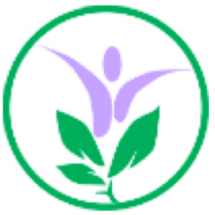
Spring Term Overview
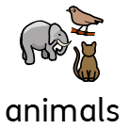
Class: 6th Form Hive
Towards Employment | Independent Living | Community Inclusion
Our key text This term is Apes to Zebras.  We will be working on our listening skills and  identifying the sounds and animals that we are hearing when learning in a variety of contexts. We will be listening to and following instructions linked to learning about animals, such as in art.  We will take part in a range of sensory walks in and around school, using objects of reference, photographs and symbols to support this.  We will be using our skills to make clear choices, whether reaching out, using images to make choices or through gesture | We will be developing our independence skills by preparing different baked and other items, following recipes and instructions in small steps as independently as possible and engaging in the different sensory items, smells and textures. We will be visiting supermarkets to purchase these items on a weekly rotation.  We will be applying our switch skills to activate everyday items, such as lights and music and also when baking. We will be increasing our confidence in using switches for different purposes including pressing and holding as well as press and release. | This term we are learning about all things to do with animals. As such for our regular visits, we will be going to places where we might see some wonderful animals, such as milestone ranch.  We will also be visiting various local cafés and eateries in order to get out and about in the community, developing our understanding of different social settings.  We will be taking part in sensory and visual walks within the school environment, identifying and engaging in the different environments and making choices wherever possible.
Health | Extended and Enriched | Careers
We will be learning about and looking at personal hygiene, what we need to do to stay clean and healthy including daily routines. We will also be looking at healthy habits linked to food preparation.  We will be using the swings both inside and outside and focusing on ball and target games. | We will be focusing our art work on representing the different animals that we are looking at and their habitats.  We will be enjoying listening to and talking part in playing music with Rosie each week. | Through a variety of activities, including work experience and visits, we will be learning about people who work in animal care. We will be working as a team and also working independently to improve our cooking skills.

