Communication/Language & Literacy | PSED | Physical Development
In Communication, Language & Literacy, we will be working on our mark making skills, our social interaction and making choices via our preferred method of communication, we will do daily Launchpad to Literacy/communication sessions, using switches, signs, symbols/photos/objects, and interacting with our friends. Our key texts are going to be: Noisy Farm, Penguin Small and The Monkey Puzzle. We will also look at factual books about winter/spring and animals of all kinds, as well as different aspects of celebrations from around the world. | In PSED we will look at how we can build relationships, interact with our friends and explore the engage with the wider school community. We will learn about personal hygiene and how we can manage our feelings and emotions, helping others and being kind, as well as keeping safe. We will learn about keeping active and eating well via our sensory baking/cooking sessions. We will also look at special days and festivals such as: Chinese New Year, Children’s Mental Health Week, Heatherwood’s Got Talent and how we can celebrate these. | In Physical development, we will follow our postural management and MOVE programme, as well as access different aspects of gross motor skills via PE sessions in the hall and in soft play/sensory mat sessions. We will work on all our physical skills including fine skills using a cross curricula approach through our many different sessions in the day, as well as our free choice sessions, and look at ways in which we can challenge ourselves physically in line with our winter/spring, animals and celebration’s topics.
Mathematics | Expressive Arts & Design | Understanding the World
We will be looking at all aspects of math we will look at counting songs, numbers, patterns, shapes, puzzle work, size: big/small, sorting, more/less and positional language linking many of these to our animal’s topic, to aspects of winter/early spring, and any celebration’s topics. We will do this in discrete sessions as well as in a cross curricula way both in the classroom, outside and around school. | In Expressive Arts and Design: we will look at and explore various aspects/genres of music that reflect different celebrations, animals and seasons. We will make/play various musical instruments, as well as make choices, keeping the beat/rhythm with favoured counting songs and rhymes. In Art and Design, we will create winter pictures and pictures based around our texts; and explore doughs/clay and different media. We will also create different pictures around animals, and celebrations by being creative with different everyday materials. | In Understanding the World: we will be looking at aspects of seasons, and learning about all kinds of animals, celebrations around the world; and our wonderful world both far away and around us, via exploring our local community. We will look at different environments in the local area and the animals that live there; we will also explore and use everyday materials and see what we can create with these. This will be explored on a sensory level, through smells, touch, sounds etc., as well as via PowerPoints, ICT, books, small world, role play and first-hand experiences in our wildlife/sensory garden.
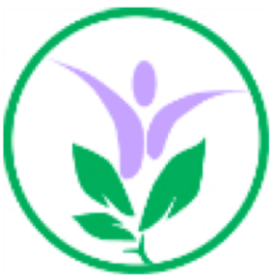
Spring Term Overview
Class: Early Years
Topic: Winter/Spring: Animals near and far.

