Remote Learning Early Years Class: Spring 2026

Shared Stories
We are looking animals near and far and celebrations. As part of this please click on the link to share our main stories which are: Penguin Small and Noisy Farm: https://www.youtube.com/watch?v=0cDby-q1BTg
Noisy Farm (Share a Story Corner)
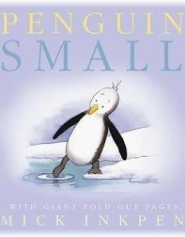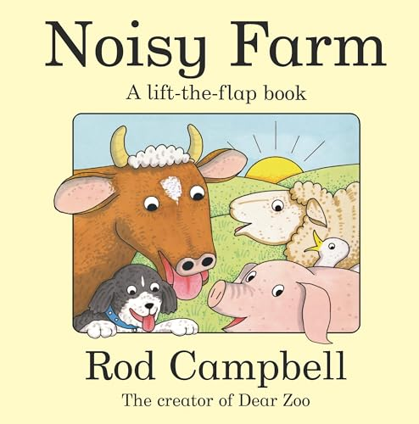

Cognition and ICT
Please click on the link to access lots of different sensory activities for you to try at home.
SEN Teacher ⋆ Light Box ⋆ Free Arts & Sensory Software Download
Counting songs: Try these counting songs: 5 Little Penguins
https://www.youtube.com/watch?v=72pm_Y6iUrM
https://www.youtube.com/watch?v=7lsrm-kAmfY
Music: Listen to relaxing winter music such as:
https://www.youtube.com/watch?v=PoJJBwNcHKk
Make winter music using various things such as bells etc to join in the session.
Think of a celebration like Chinese New Year and try listening to lots of different genres of music that you might here during it!

Creative and exploratory play
Focus: Create a penguin/polar bear or farm yard collage or you could even make a polar landscape. Or see if you can create some warm clothes to wear in winter.

Equipment: different materials, paper, glue and paint.
The focus will be to create a collage/ picture with the different materials that you have found, or to help create a landscape for polar animals or farm animals or even clothes to keep you warm in winter.
Or you could try: Finding out about the Chinese New Year (this year it is the Year of the horse) and create Chinese themed artwork and listen to Chinese music.
What can you see in your garden? As we are exploring animals and looking at winter and signs of spring can you find things connected to winter: ice/frost/snow or you could even try freezing leaves. As time goes by can you see signs of spring such as bulbs, flowers, or can you even help to plant seeds/bulbs ready for spring!

Cookery: Peppermint Polar Bears.
Focus: To explore different ingredients in a multisensory way and to follow a recipe (see recipe).
Peppermint Polar Bears: https://www.bbcgoodfood.com/recipes/polar-bear-peppermint-creams

Or try lots of different types of Chinese Food in line with Chinese New Year which this year begins on the 17th February.

