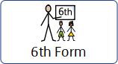
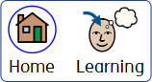

Spring Term Home learning
Class: The Key
Towards employment | Community Inclusion
  Can you explore different coins and notes and use real money to make a payment in a shop with your supporting adult.    How much change would you need?  Do you have enough money to buy your items?  Can you have a go at drawing inferences from a text?  IXL - Draw inferences from a text (Year 4 English practice) |   During weekly travel training,    we will be catching the bus  into town using the first bus app.  Can you explore the app and plan a  route from your house?  Can you read a bus timetable with adult support. What busses can you catch from your home and to where.
Health | Independent living
What does friendship mean to you?  Can you identify 3 qualities in your friends and when you next see them, tell them their qualities.   | What does healthy eating mean?  Can you make a spaghetti bolognese using these ingredients?  - Lean minced meat  - Onions  - Garlic  - Peppers  - Tomato puree  - Whole wheat pasta  Can you add any herbs or spices?

