Rolling Programme
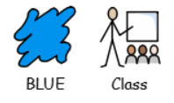


 | AUTUMN TERM | SPRING TERM | SUMMER TERM
YEAR 1 |   SPACE |   ANIMALS |   TOYS & MACHINES
YEAR 1 | The Darkest Dark  You Are Here : Around the World in 92 Minutes Chris Harding | How do meerkats order pizza?  The Enormous Crocodile- Roal Dahl | The Iron Man (and the Iron Giant)  Minecraft: Crack in the Code! Stonesword Saga
YEAR 2 |   CELEBRATIONS | 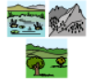  ENVIRONMENTS |   FOOD
YEAR 2 | A Christmas Carol  Home Alone | The Lorax  Boy- Roald Dahl | Cloudy with a Chance of Meatballs  Charlie and the Chocolate factory

