ARC Rolling Programme



 | AUTUMN TERM | SPRING TERM | SUMMER TERM
YEAR 1 |   BACK TO SCHOOL BLAST OFF |   CELEBRATIONS |   ADVENTURES AWAITS
YEAR 1 | 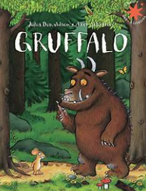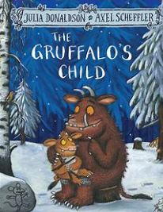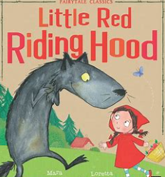 | 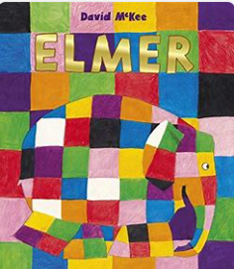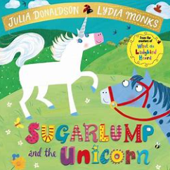 | 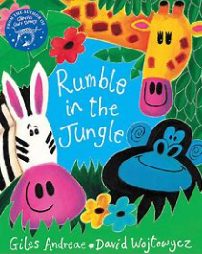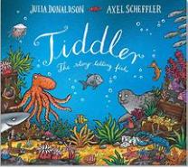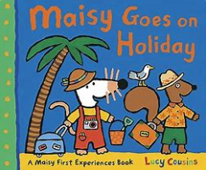
YEAR 2 |   ALL ABOUT ME |   CARNIVALS |   NATURE AND ANIMALS

