Communication/Language & Literacy | PSED | Physical Development
In Communication, Language & Literacy, we will be working on our social interaction and making choices via our preferred method of communication, we will do daily Launchpad to Literacy/communication sessions, using switches, signs, symbols/photos/objects, and interacting with our friends. Our key texts are going to be: Can’t you sleep little bear, Stickman, catch a falling star and other autumn-based texts. We will also look at factual books about autumn, our world, families, festivals and celebrations, as well as developing our early mark making skills. | In PSED we will look at how we can build old and new relationships, interact with our friends and explore the engage with the wider school community. We will learn about personal hygiene and how we can manage our feelings and emotions, helping others and being kind, as well as keeping safe. We will learn about keeping active and eating well via our sensory baking/cooking sessions. We will also look at how we celebrate special days and festivals such as: Harvest Festival, Children in Need, Remembrance Day, Diwali and Christmas. | In Physical development we will follow our postural management programme and MOVE programme, as well as access different aspects of fine and gross motor skills via PE sessions in the hall and in soft play/sensory mat sessions. We will work on all our physical skills using a cross curricula approach through our many different sessions in the day, as well as our free choice sessions, and look at ways in which we can challenge ourselves physically in line with our festivals and celebrations topic, as well as during the seasonal changes we experience.
Mathematics | Expressive Arts & Design | Understanding the World
We will be looking at all aspects of math we will look at counting songs, numbers, patterns, shapes, puzzle work, problem solving, size: big/small, measure, size and order, sorting, more/less and positional language linking many of these to our autumn/early winter and family and festival’s theme. We will do this in discrete sessions as well as in a cross curricula way both in the classroom, outside and around school. | In Expressive Arts and Design: we will look at various aspects of music that illicit feelings about autumn/early winter, family life and festivals. We will explore different genres of music such as autumn and festival music and make/play various musical instruments, as well as make choices, keeping the beat/rhythm with favoured counting songs and rhymes. In Art and Design, we will create autumn/winter pictures, and family and festival pictures and explore doughs/clay and different media. We will also create different models linked to the festivals we will be exploring, by using different natural and everyday materials. | In Understanding the World: we will be looking at aspects of autumn/early winter, and learning about family life and different festivals and celebrations around the world, as well as exploring in our local community. We will look at different environments in the local area such as woods/ponds and the animals that live there; we will also explore and use everyday materials and see what we can create with these (autumn creatures, habitats etc). This will be explored on a sensory level, through smells, touch, sounds etc, as well as via PowerPoints, ICT, books, under the sea small world and role play and first-hand experiences in our wildlife garden.
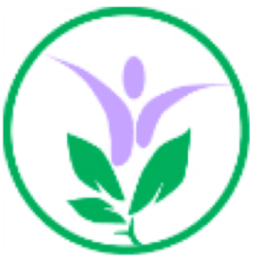
Autumn Term Overview
Class: Red Panda
Topic: Autumn/Winter: My family, festivals and celebrations!

