
Home Learning

Class: Tiger Class Term: Autumn

These activities are suggestions of learning activities you could complete at home with your young person. They are not compulsory but compliment the learning taking place in the classroom. Please share any work or photographs with us using Seesaw, we love to see what you have been doing at home!

Community Inclusion | Independent Living
  During weekly travel training,    we will be catching the bus  into town using the first bus app.  Can you explore the app and plan a  route from your house?  Can you read a bus timetable with adult support. What busses can you catch from your home and to where.  We will also be working on road safety and building confidence crossing roads safely.  Go for a walk with an adult and practice using various types of safe crossings. | What does healthy eating mean?  Can you make your favourite lunch?  We are also building pupils independence around the home.  Can you make your own bed and change the sheets?  Take photos of you doing these things at home and post them on Seesaw
Towards Employment | Health
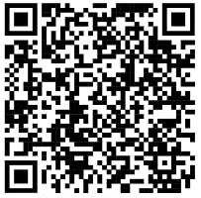  Can you explore different coins and notes and use real money to make a payment in a shop with your supporting adult.    How much change would you need?  Do you have enough money to buy your items?  Literacy shed is a great way to use images and video clips as a stimulus for discussion or writing. Literacy Shed - Teaching Resources Made Easy | At the end of each day, tell an adult at home one thing that has happened at school that made you feel proud.  

